Dear participant,

Thank you for taking the time to complete this coding exercise. We truly value the information you have provided. Your responses will contribute to our analyses of the texts.

Once again, we are extremely grateful for your contributing your valuable time, your honest information, and your thoughtful suggestions.

Many thanks,

Juandre van Heerden

Student number: 211144843

Email: s211144843@mandela.ac.za

The coding exercise will consist of 2 main tasks:

1. Completing the Title + Abstract coding spreadsheet.
2. Completing the Clusters coding spreadsheet.

Task 1: Completing the Title + Abstract coding spreadsheet.

Step 1: Open the excel document named “Coding – Title + Abstract”.

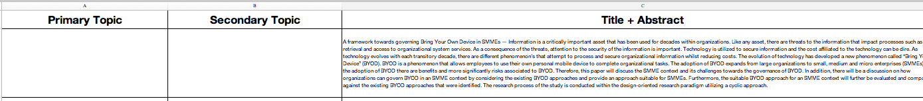Step 2: Read through the papers title and abstract provided in the Title + Abstract column.

Please note: Only one option can be select for each topic.

Step 3: Once completed, select the most accurate primary topic from the drop-down box.

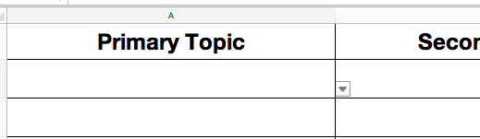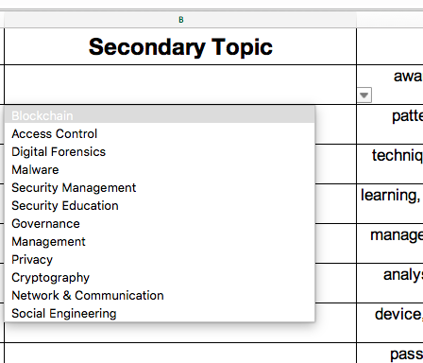

Please note: Some papers will have secondary topics, for those cases there is a column labeled secondary topics to select from.

Step 4: Once completed, select the most accurate secondary topic from the drop-down box.

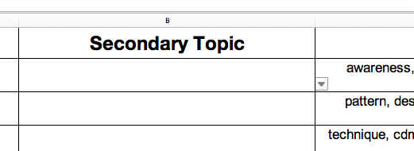

Step 5: When you have completed the Title + Abstract coding spreadsheet, email me the completed spreadsheet on [s211144843@mandela.ac.za](mailto:s211144843@mandela.ac.za)

Task 2: Completing the Clusters coding spreadsheet.

Step 1: Open the excel document named “Coding – Clusters”.

Step 2: Read through the clusters provided in the Clusters column.



Please note: Only one option can be select for each topic.

Step 3: Once completed, select the most accurate primary topic from the drop-down box.



Please note: Some papers will have secondary topics, for those cases there is a column labeled secondary topics to select from.

Step 4: Once completed, select the most accurate secondary topic from the drop-down box.



Step 5: When you have completed the Clusters coding spreadsheet, email me the completed spreadsheet on [s211144843@mandela.ac.za](mailto:s211144843@mandela.ac.za)